  
  
  
  
CS 319 - Object-Oriented Software Engineering  
Final Report  
  
  
Project Name: Survival in Bilkent

Group 2-M

Pelin Elbin Günay - 21402149

Kübra Nur Güzel - 21400946

Alper Şahıstan - 21501207

Semih Teker – 21300964

Table of Contents

1. Changes in the Implementation 3

1.1. Change in Libraries 3

1.2. Removal of EnemyBullet Class 3

1.3. Change in Dynamic Game Object 3

1.4 Abstract Shape Class 3

1.5 Menu Inheritance 3

1.6 State Based Game 4

1.7 GameMaster – BasicGameState 4

1.8 Player Object Pattern Change 4

1.9 Behavioral Changes in the Enemies 4

2. Status of the Project 4

3. User’s Guide 5

3.1. System Requirements 5

3.2. Installation 5

3.3. Overview of the Game 5

3.4. Game Entities Subsystem 6

3.4.1 Game Objects 6

3.4.2 Controls 6

3.4.3 Game Screenshots and Menus 6

# Changes in the Implementation

### Change in Libraries

Instead of AWT Swing we have decided to use Slick2D library for our project. This will allow us not to write a Vector2 class and use Vector2f class from the library for our game screen.

### Removal of EnemyBullet Class

We have decided to remove EnemyBullet class from our hierarchical system which was located under Game Entities Subsystem. To replace that, inside of the Bullet class, isEnemyBullet boolean will be created.

### Change in Dynamic Game Object

Instead of Vector2f velocity we are now holding float speed since movements of our objects can be defined in one dimension.

### Abstract Shape Class

Each game object will hold an instance of an abstract class “Shape” (comes from the Slick2D library) and this class will be initialized to a non-abstract “Shape” in Game Objects non-abstract child classes. (in GameObjects: Shape shape; in Player (grandchild of Game Object): shape = new Oval (3,2, 10, 15)

### Menu Inheritance

Main menu and title menu are same things right now. We used to call it Main Menu but now it is Title menu and it is the first thing the player encounters when entering the game. This is where the user enters his/her name, sees buttons “Play!” or “Exit!”.

### State Based Game

The game designed to be inherited State Based Game and created Survival in Bilkent. Title Menu and Upgrade Phase is also BasicGameState. The switching between states is handled by Survival in Bilkent class.

### GameMaster – BasicGameState

GameMaster is now a child of BasicGameState. GameMaster became a state now.

### Player Object Pattern Change

Player object is now using the Singleton Pattern in order to use it as a global variable and reach it from other BasicGameState.

### Behavioral Changes in the Enemies

We have added some new features to different enemies for immense amounts of fun!

Assignment Enemy has a shield which needs to be down in order to take damage and also, if not taken damage for 3 seconds the shield restores.

Midterm Enemy is an octagonal – square MorphShape. It shoots triple bullets. When it’s health is below 40, it enters a new state where it shoots bullets in a laser form, continuous shooting.

Final Enemy is also a MorphShape which alternates between a hexagon and a circle. It also has a unique attack pattern. It shoots 5 bouncy bullets and then shoots a big missile-like bullet which is not bouncy. It also has a shield and after it’s shield is down, Final

Enemy launches itself aiming to the player.

# Status of the Project

We have worked our way through “Survival in Bilkent” but it is not fully complete but it is very close to its final status.

# User’s Guide



## System Requirements

Survival in Bilkent is a Java based game. For this reason, Java Run Environment should be present and installed to the computer in order to start the game. It can be downloaded from the following link:

<http://www.oracle.com/technetwork/java/javase/downloads/index.html>

Minimum System Requirements:

• Windows XP

• Pentium2 233 MHz CPU or higher.

• 256 MB of RAM or higher

• Screen resolution: 1080x1920

Recommended System Requirements:

• Windows 10

• Intel i5 2 GHz CPU or higher

• 1 GB of RAM or higher.

• Screen Resolution: 1080x1920

## Installation

Running and compiling our code with a Java IDE is the only way to play our game at the moment. We are planning to make an executable without needing a Java IDE.

## Overview of the Game

When the player chooses the play option from the Title Menu game starts. There is an empty map on the screen. There is a player icon and some enemies spawning. Player can move around the map using W, A, S, D buttons; aim and shoot with the mouse input. If the enemies take damage that is equal or more that their health, enemy dies and disappears from the map. Enemy health is visible on the enemy’s icon and decreases when bullets hits the enemy.

## Game Entities Subsystem

## Game Objects

* **Player:** That is the main object that the user controls which can move and shoot.
* **Bullet:** Player can shoot bullets that does damage to enemies.
* **Enemy:** Different type of enemies will be present in our game. Right now, there is only the “Bug” enemy can only chase down the player and try to damage it via collisions.
* **Collectables:** Objects that will give small bonusses to the player.

## Controls

* **W:** Move north
* **S:** Move south
* **A:** Move west
* **D:** Move east
* **Mouse:** Aim
* **Mouse Left Click:** Shoot
* **Mouse Right Click:** Apply the power-up

## Game Screenshots and Menus

**Title Menu:** The first thing user came across in the game is this main screen where he/she can enter their names, chose to start the game, quit the game, or see the credits.

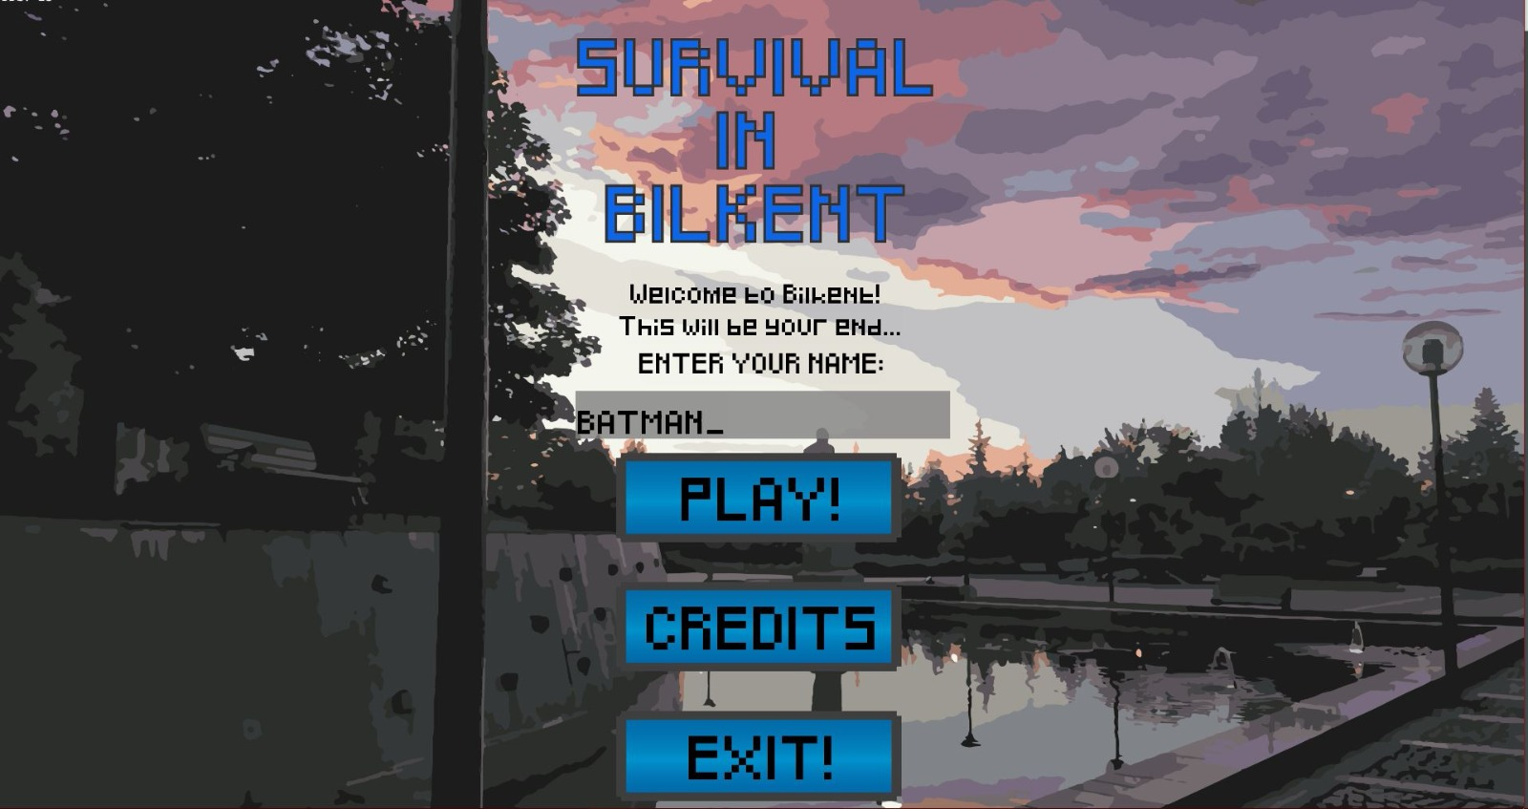

**Credits:** Developers of the game will be shown here.

**Play:** This is the game screen and player will be playing the game on this screen. The player will encounter with different types of enemies while playing.

**Types of Enemies:**

**Lab Enemy:** Lab enemy is a very slow enemy. It cannot shoot but it produces a lot of Bug enemies. Bugs also cannot shoot but they chase the player and damage it by collision.

As it can be seen from the following image, light green rectangular one is the Lab Enemy itself, other small dark green squares are Bug Enemies produced by the Lab Enemy.

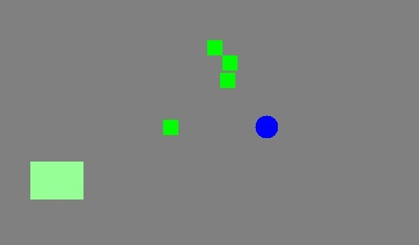

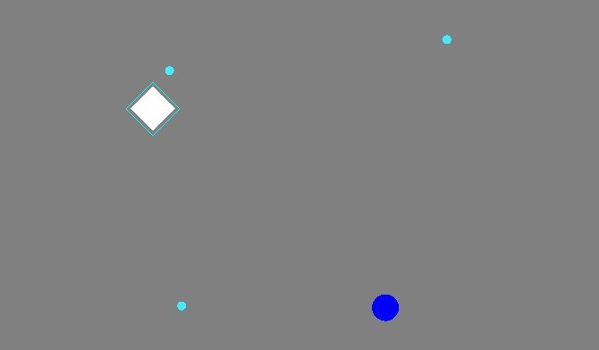**Assignment Enemy:** Assignment slow but it has a shield. It cannot shoot. Its shield needs to be taken down with 3 straight hits. When the shield is down, if the enemy is not taken damage within the next 3 seconds Assignment will gain shield again.

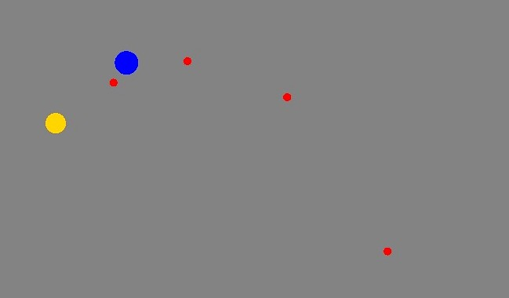**Quiz Enemy:** Quiz enemy is very fast, it can also shoot. But it has low health and low damage.

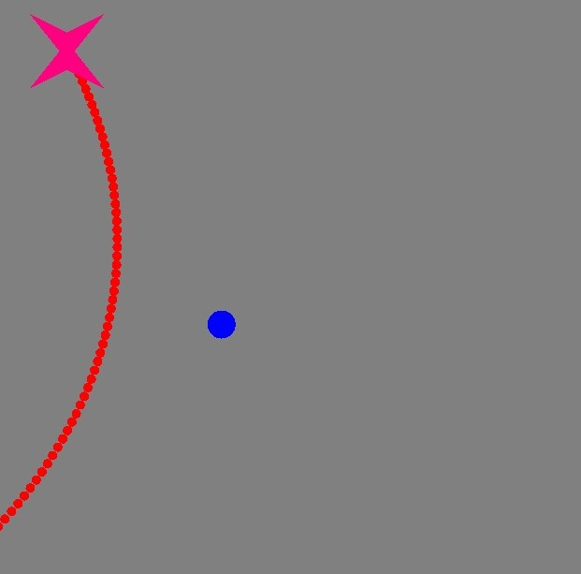**Midterm Enemy:** Midterm is one of the hardest enemies to defeat. It shoots triple bullets. When its health is below 40 it enters to another phase called “Revenge of the Revised Midterm” where it starts to shoot bullets like a laser, it shoots continuously.

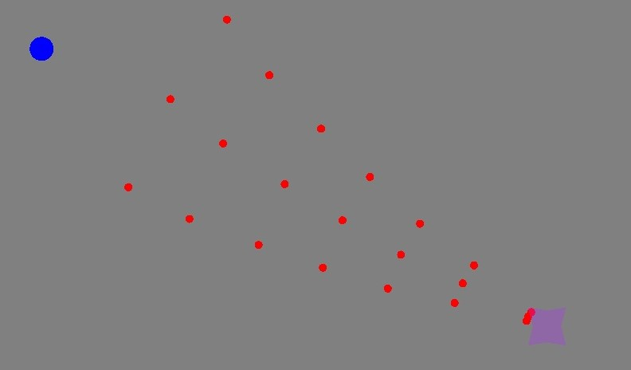

**Final Enemy:** Final is the boss of every level. It is by far the hardest enemy to kill. It shoots 5 bouncy bullets, a big bullet that has double damage of a regular bullet. It has a shield that the player has to take down before making any damage. Also, when the shield of the Final Enemy is down, it launches itself like a catapult towards 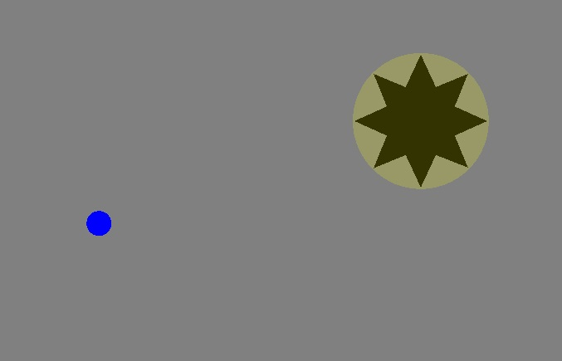the player to deal body damage.

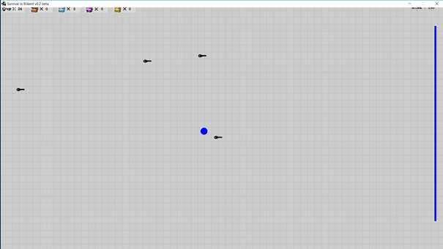**Collectables:** There are collectables in the game such as keys and chests that will spawn randomly on the map. Upper lest corner of the screen will show the amount if each collectable.

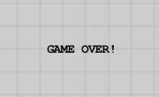**Game Over Sign:** Appears on the screen when player runs out of time. A simple “Game Over” appears at the center of the screen.